Greener Earth

A website on Climate Change



**INFORMATION SYSTEM DESIGN AND SOFTWARE ENGINEERING LAB**

Data flow and use case diagram

Submitted by

**Samin Shahriar Tokey** | 14-02-04-066

**Biozid Niloy** | 14-02-04-070

**Naimul Haque** | 14-02-04-080

**Sanaul miraj** | 14-01-04-131

**Data Flow Diagram:**

A data flow diagram (DFD) is a graphical representation of the flow of data through an information system, modeling its *process* aspects. A DFD is often used as a preliminary step to create an overview of the system without going into great detail, which can later be elaborated. DFDs can also be used for the visualization of data process.

**Notation used in DFD:**

Entity

Process

Data Storage

Data Flow

**Types of Data Flow Diagram:**

1. Context Diagram
2. Level 1 Diagram
3. Level 2 Diagram

**1.Context Diagram(Level 0):**

DFD Level 0 is also called a Context Diagram. It’s a basic overview of the whole system or process being analyzed or modeled. It’s designed to be an at-a-glance view, showing the system as a single high-level process, with its relationship to external entities. It should be easily understood by a wide audience, including stakeholders, business analysts, data analysts and developers.

**Context Diagram of Greener Earth:**

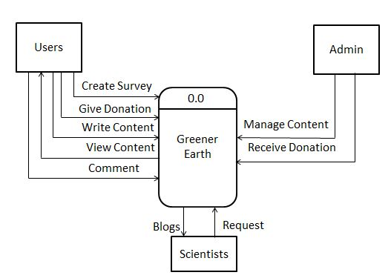

**Description:**

From context diagram we can see that we have three entities in our system. The entities are users, scientists, admin. User can take survey, give donation, write content to the system, view content from the system, comment on contents of the system. Admin can manage all content and receive donation from users. Scientists can post blog on the system, admins will fetch and filter them.

**Level 1 Diagram:**

DFD Level 1 provides a more detailed breakout of pieces of the Context Level Diagram. It highlights the main functions carried out by the system, as it breaks down the high-level process of the Context Diagram into its sub processes.

**Level 1 Diagram of Greener Earth:**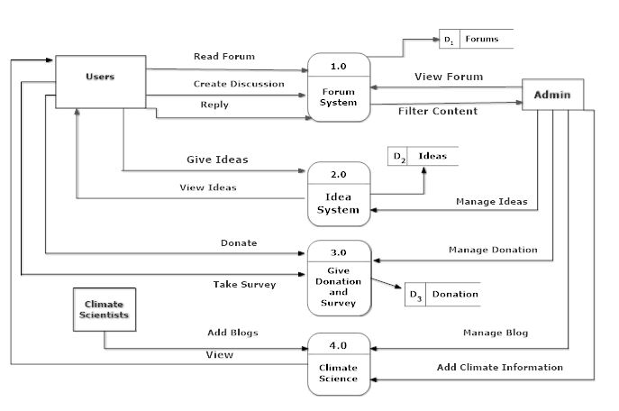

**Description:**

In level 1 diagram we break down the context diagram in several processes. In forum system process, users can create discussion, read forum and reply to the discussion. Admin can view the forum and able to filter the content of the forum. In Idea System process, user can give ideas and view ideas of other users. Admin can manage ideas. In donation and survey system user can donate and take survey. Admin will receive the donation. In Climate Science process, users can view the blogs of scientist. Climate Scientists can add blog and admin can manage the blog and add climate information.

**Level 2 Diagram:**

DFD Level 2 then goes one step deeper into parts of Level 1. It may require more text to reach the necessary level of detail about the system’s functioning.

**Level 2 Diagram of Greener Earth:**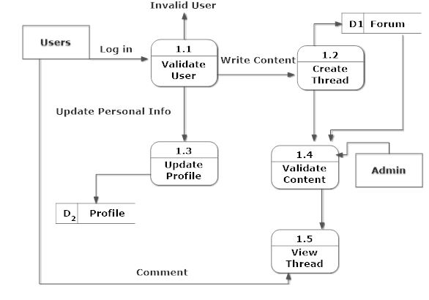

**Description:**

Here validate user process validates the user. After log in user can write content in create thread, update personal info in update profile info process. Users can view the thread and comment on thread.Admin can validate the content.

**Level 2 Diagram of Greener Earth:**

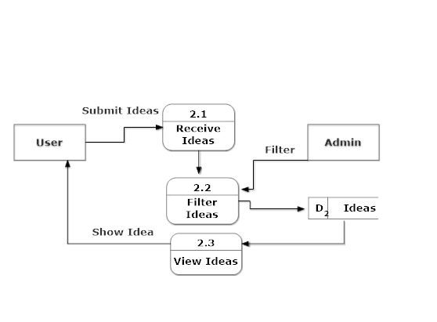

**Description:**

In receive ideas process users can submit the ideas, admin will filter the ideas in filter ideas process. From view ideas process users can view the ideas of other users.

**Level 2 Diagram of the Greener Earth:**

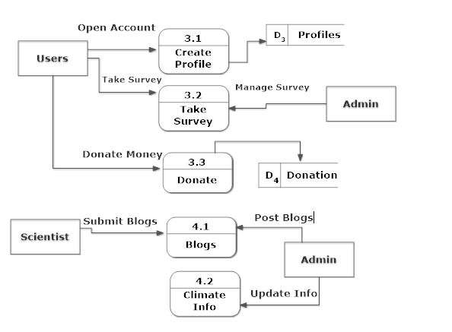

**Description:**

In create profile process user can create the profile. Users can take survey by using take survey process, admin can manage the survey. Users can donate money in donate process. Scientists can submit blogs in blog process and admin will post the blogs. Admin can update climate info by using climate info process.

**Actors:**

* Users :   
  Users will be able to create account , send donations , create forums and take survey. Any user will be able to post ideas without logging in.
* Admins:

Admins will control the control the contents of the page. He will be updating the contents that are taken from scientists, and he will also filter spams.

* Scientist:

Scientists will be contributing indirectly in this website. Admins will fetch and filter contents (Blogs) from scientists and post it in the site.

**Use Case Diagram:**

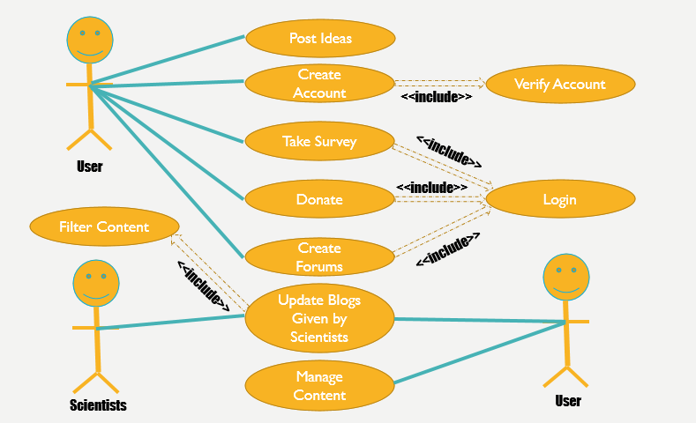

**Conclusion:**

We tried to explain data flow of the entire project and the use case of the project. We hope that it will meet the requirements of the clients.